Artificial and Computational Intelligence
Assignment 1
Tour Agent
Problem Statement:
Assume that you are to design a tour agent. The city of Delhi is going to host an international business summit, and several foreign delegates are expected to visit. The city is renowned for its rich cultural heritage and the government has included a tour of the prominent tourist locations in the city in their itinerary. They have appointed you to design a Tour Agent that is going to take care of the planning of the tour.
You are provided with a map of the city with important tourist landmarks marked. Your tour agent is to give the optimal tour route for the delegates with minimum cost.
The problem here is to find the shortest route that travels to all the tourist destinations in Delhi. The map shows important locations in the city with roads connecting them. The cost of taking a particular road is given adjacent to them. Help the agent in finding such a path given the starting point is Indira Gandhi Airport.
Use the following algorithms to solve the tour agent problem:
1. Recursive Best First Search
2. Depth First Search
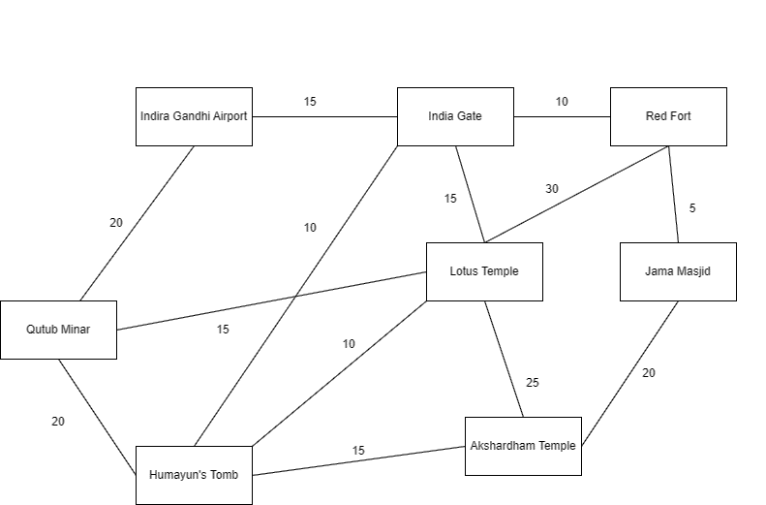

Answer the following:
- Explain the PEAS and Task environment of the agent [20% weightage]
- Define the heuristic and or fitness function for the given algorithms and the given problem. [20% weightage]
- Use appropriate data structures and implement given informed and uninformed search algorithm and Print the path taken by the agent. [40% weightage]
- Find and print space and time complexity using code in your implementation. [20% weightage]
Note:
- You are provided with the python notebook template which stipulates the structure of code and documentation. Use well intended python code.
- Use separate MS word document for explaining the theory part. Do not include theory part in the Python notebook except Python comments.
- The implementation code must be completely original and executable.
- Please keep your work (code, documentation) confidential. If your code is found to be plagiarized, you will be penalized severely. Parties involved in the copy will be considered equal partners and will be penalized severely.

